

**COMPUTER SCIENCE**

LAB REPORT SUBMISSION COVER PAGE

# **Comp Sci 361**

Fall 2021

**Student Name**: Tyler Hirn (hirntr05@uwgb.edu)

**Student Name**: Josh Stalowski (staljd14@uwgb.edu)

**Student Name**: KyuSeung Sim (simk11@uwgb.edu)

**Declaration of originality:**

I declare that all sentences, results and data mentioned in this report are from my own work. All work derived from other authors have been listed in the references. I understand that failure to do this is considered plagiarism and will be penalized.

*Note that* c*ollaboration and discussions in conducting the experiments are allowed but copying and any act of cheating in the report, results and data are strictly prohibited*

Student signature: Tyler

Student signature: Josh

Student signature: KyuSeung

**Experiment title**: Group Assignment – Group 7

Lab 8 Section 2 ~ Lab 10 Section 2

**Experiment Date**: 11/06/2021 ~ 11/28/2021

**Date Submitted**: 11/28/2021

**Lab Instructor Name**: Nazim Choudhury

Lab 8 Section 2

1. Lab Report file including screen captures of the following:
   1. Xss form showing yourname;

* 1. Xss form showing the vulnerability pop-up alert;

* 1. Submissions that return a response for scripts used to determine the number of columns in a table;
     + The first two queries give no feedback while the third one gives an error as in the picture.

* 1. Submissions that return a response for scripts seeking the correct spelling of a field name;

* 1. Submissions that return a response for scripts that search for a possible hit on the database’s characters;

* 1. SQL injection user hash information;

1. Additional Component
   1. Create a SQL injection attack to determine the correct field name that holds the user’s surname
      * a' UNION ALL SELECT system_user(), user();#
2. Bonus mark
   1. As you discovered in this lab that the password hash was included in the mysql.user database; however, there is another database that contains user data. What is the name of that database, and what content can you uncover within it

Lab 9 Section 1

1. Lab Report file including screen captures of the following:
   1. Virus details;

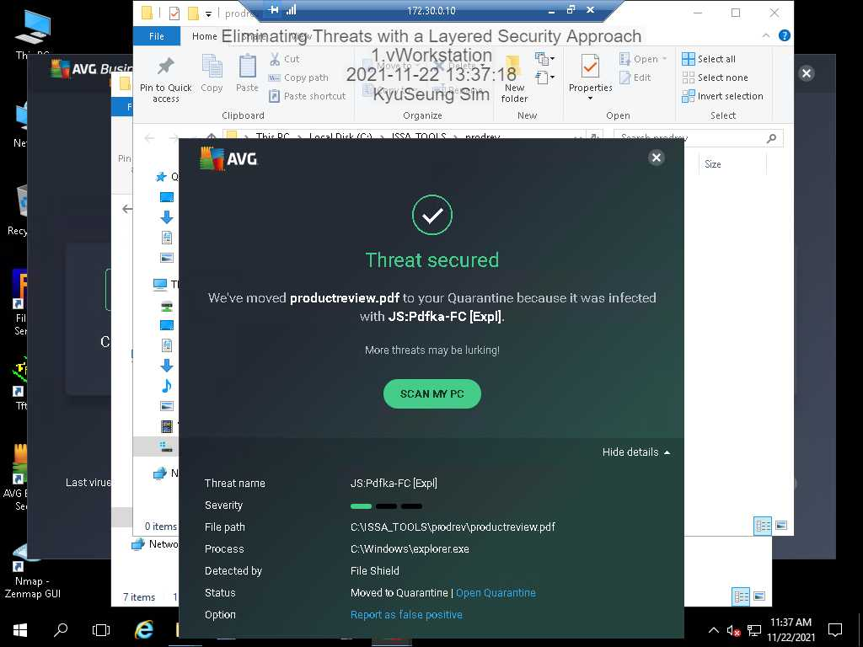

* 1. Emptied Quarantine area (Virus Vault);

* 1. Updated services list;

* 1. Updated File and Printer Sharing rule in the firewall;

* 1. Inbound FileZilla Server rule;

Lab 9 Section 2

1. Lab Report file including screen captures of the following:
   1. AVG Detection window;

* 1. Additional threat details;

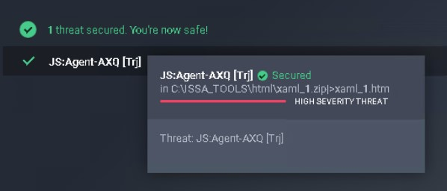

* 1. Emptied Quarantine area (Virus Vault);

* 1. Updated services list;

* 1. Updated Email and accounts rules in the firewall;

* 1. Outbound FileZilla Server rule;

1. Additional Component
   1. Research Windows services. Using the screen captures you made in Part 2 (disabling unwanted services) of the lab, identify at least three additional services that could be disabled safely. Explain your choices.
      1. Windows Mobile Hotspot Service
         * This service provides the ability to share a cellular data connection with another device. This service only works on the laptop or surface device that uses cellular data. Regularly, Normal PC and laptops didn’t use cellular data.
      2. Downloaded Maps Manager
         * This service is that Windows service for application access to downloaded maps. This service is started on demand by application accessing downloaded maps. Disabling this service will prevent apps from accessing maps. Many windows user doesn’t know the window’s maps exist.
      3. Xbox Live Game Save
         * This service sync save data for Xbox Live save enabled games and this service is stopped, game save data will not upload to or download from Xbox Live. As a result, a Business or Employee’s PC doesn’t need to use the Xbox Live application to use.
      4. Remote Desktop Services
         * This service allows users to connect interactively to a remote computer. Only a few people use this remote desktop service.

Lab 10 Section 1

1. Lab Report file including screen captures of the following:
   1. Newly configured Domain Password Policy;

* 1. Newly configured Account Lockout Policy;

* 1. Student user account logged on to TargetWindowsMem03;

* 1. Administrator account logged on to TargetLinux;

1. Additional Component
   1. In this lab, you changed the Audit Policy to record both successful and unsuccessful login attempts. What drawbacks do you foresee when Auditing is enabled for both success and failure?
      * When changing the Audit Policy to record to both successful and unsuccessful login attempts, there are a few drawbacks. The first drawback is that if the system is under load and a brute force attack occurs, it can cripple a system. Another drawback could be an overall reduction in the server’s performance. One last drawback could be the reduction of storage space with the amount of audit logs having to occur.

Lab 10 Section 2

1. Lab Report file including screen captures of the following:
   1. Newly configured Domain Password Policy;

* 1. Newly configured Account Lockout Policy;

* 1. Student user account logged on to TargetWindowsMem03;

* 1. Administrator account logged on to TargetLinux01;

